Let's Stay Connected

PowerSchool Community at <https://help.powerschool.com> is where you will find the latest product information, such as release notifications, customer advisory board meeting information, knowledge base articles, and customer forums.

Going forward, the Product Management team will use Community as our primary communication method to share product information, instead of direct emails or calendar invitations. Please make sure you have access to the Special Programs area on Community and consider subscribing to the topics that interest you. Below you will find information on how to:

* Get access to Community
* Find information about Special Programs
* Subscribe to receive email notifications
* Use labels to filter information

# Get Access to Community

Some information on Community is available publicly, but most of the information requires that you sign in with a Community account tied to your PowerSource account to authenticate you as a PowerSchool tech contact (aka designated support contact) for your district or school. If you need to be added as a tech contact, please reach out to Support to help you.

Even if you've never visited the Community site, we may have created an account for you on Community based on your PowerSource account. If so, you may just need to reset your password. Otherwise, creating an account is quick and easy.

## To check your access for Community:

1.     Go to <https://help.powerschool.com>

2.     Click **JOIN THE COMMUNITY**  
  
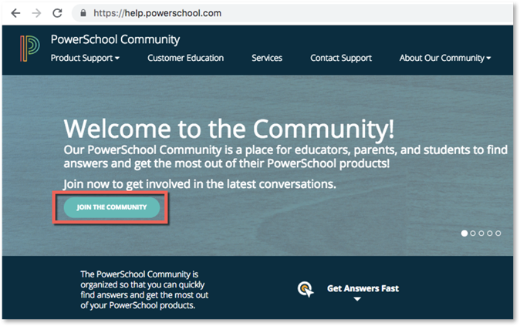

3.     Click **Register Now**

4.     Jump down to Email and enter the email associated with your PowerSource account  
  
If you see the message "The email address is already used by another account" then at the top of the form, click **sign in  
  
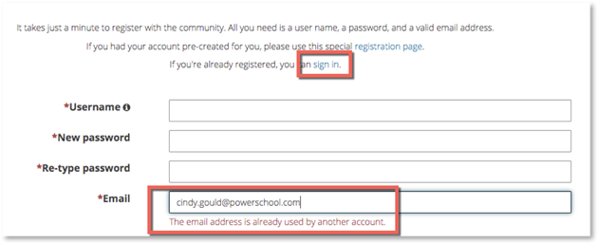**Back on the Sign In page, click **Forgot username or password?**Enter the email associated with your PowerSource account and click **Set a new password**

5.  If your PowerSource email is not already used by another account, go ahead and fill out the rest of the registration form and click **Register**Be sure to use the email associated with your PowerSource account so that you will have the proper permissions on Community.

6.  Look for a confirmation email and click the activation link  
  
For more info on registering on Community, click **Help** at the top right corner and select **Getting Started**.

# Find Information About Special Programs

After signing in on the Community site, from the top menu, select Product Support > Special Education > Special Programs. Here you will see links to the customer forum, the knowledge base that Support maintains, and last but not least, Special Programs Product Updates. This is our area to share information with you.  
  
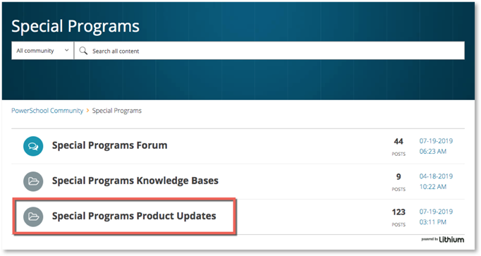

On the Product Updates page, choose a topic to view posted articles. Articles are basically web pages where we can add text, links, attachments, images, and videos.

Currently, we are using three topics for articles from Product Management:

* Special Programs Platform Release Notifications: articles about platform or core product releases and other related news
* Special Programs Provincial or State Release Notifications: articles about province or state releases, customer advisory board meeting info, and other news pertaining to a particular model.
* Special Programs Product Communications: articles with general product information we think will be helpful for all customers.   
  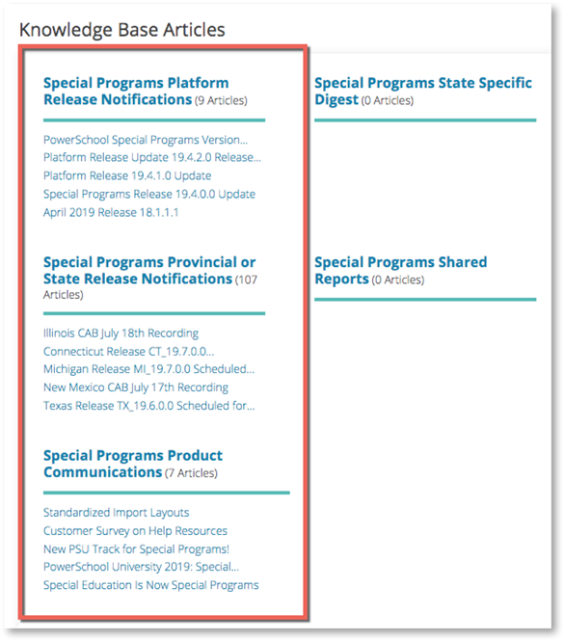

# Subscribe to Receive Emails

Subscribe to a topic to receive an email whenever we post a new article for that topic. When viewing a topic, open the OPTIONS menu and select Subscribe.

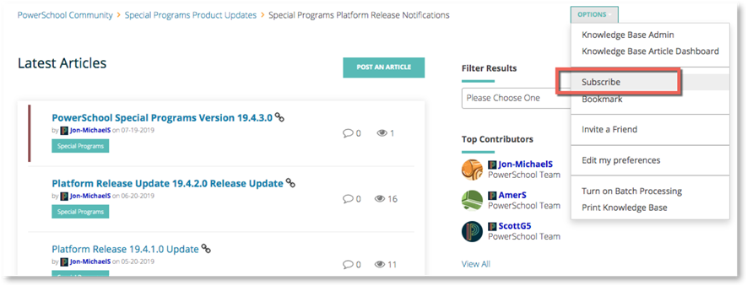

# Use Labels to Filter the List of Articles

When you see a Filter Results menu at the right side of the page, you can select a label to filter the list of articles for content tagged with that label. Labels are especially helpful for province- or state-specific articles, such as release notes or advisory board meeting information. Select a label and bookmark the page for quick access to the filtered list of articles. To receive an email notification when an article is posted with that label, at the top of the list of articles, click Subscribe.

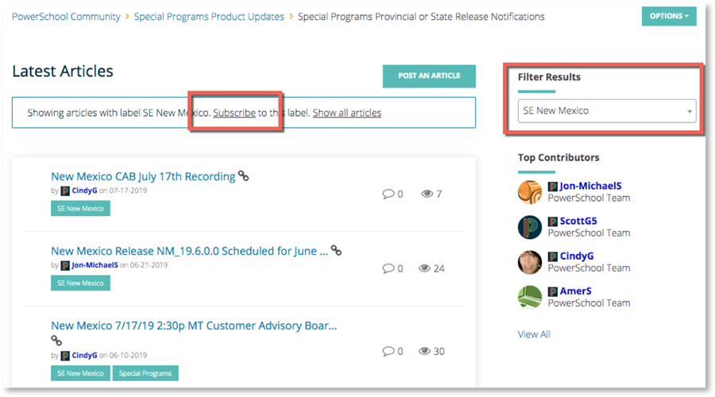

If you have any questions or issues with PowerSchool Community, please contact Support. We look forward to seeing you on Community!